**Assignment – 13**

**Assignment Title:**

# Practice OLAP queries for ranking and group by.

**Program:**

Create databse samiksha;

Use samiksha;

Create table sales(

rownum int,

name varchar(20),

region varchar(20),

sales int

);

Insert into sales values

(1,’Vaibhav’,’west’,5000),

();

mysql> select * from sale;

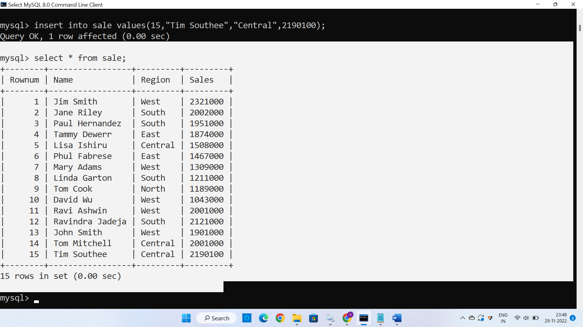

mysql> select Rownum as 'rank', Name, Region, Sales from (select Rownum, Name, region, sum(Sales) as Sales from sale group by Name, Region order by sum(Sales) DESC) as sale_record where Rownum <= 10;

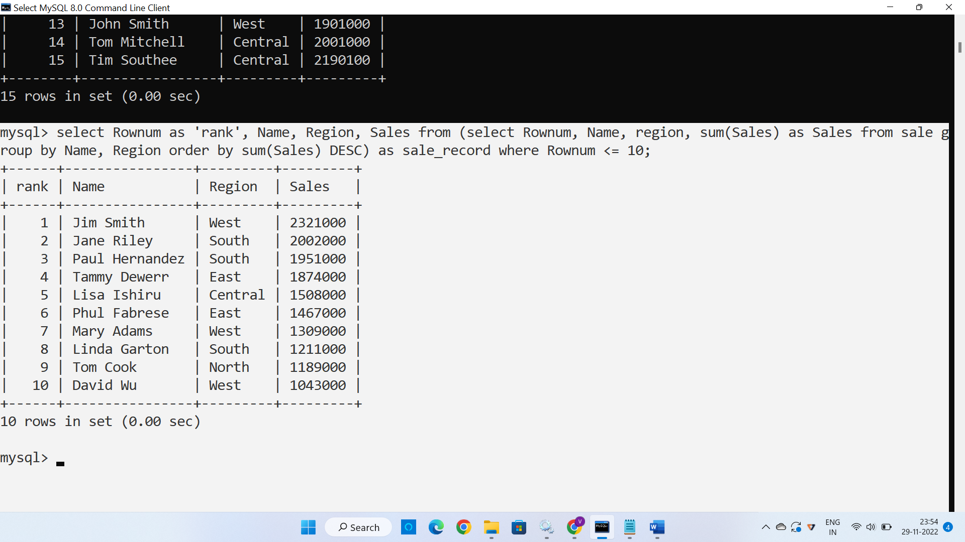

**MySQL rank() Query :**

**If we partition by name as well as region then query be like :**

mysql> select Rownum, Name, Region, Sales, rank() over (partition by Name, Region order by Sales desc) as 'rank' from sale;

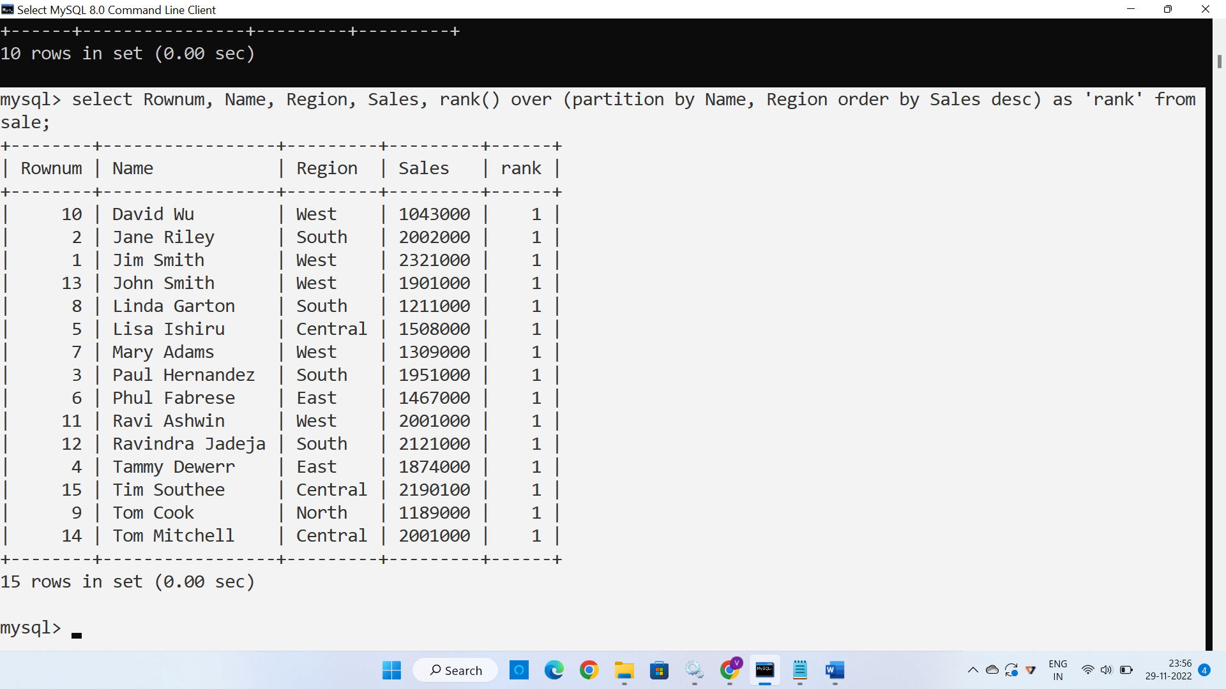

**If we partition by region then ranking be like :**

mysql> select Rownum, Name, Region, Sales, rank() over (partition by Region order by Sales desc) as 'rank' from sale;

